





**AIM:** To build and configure simple network topology using CISCO Packet Tracer.

Packet Tracer is a network simulation program that allows students to experiment with network behaviour and ask “what if” questions. Packet Tracer provides simulation, visualization, and authoring, assessment, and collaboration capabilities and facilitates the teaching and learning of complex technology concepts.



# Expected Outcome of Experiment:

**CO1:** Explain the fundamentals of the data communication networks, reference models, topologies, physical media, devices, simulators and identify their use in day to day networks



# Books/ Journals/ Websites referred:

1. [http://www.google.com](http://www.google.com/)
2. A. S. Tanenbaum, “Computer Networks”, Pearson Education, Fourth Edition
3. B. A. Forouzan, “Data Communications and Networking”, TMH, Fourth Edition
4. [CISCO PACKET TRACER 8.0.1 and Higher version (free download)](https://mega.co.nz/#!q4p0wS7Z!J9jkMwXzZSO4zP1kZX632VFYyxNzwPUhvx8f8Ejyen0%20(53.3%20MB))



**Pre-Lab/ Prior Concepts:** Simple Network flow



**New Concepts to be learned**: Purpose of this lab is to become familiar with building topologies

in Packet Tracer.



# Stepwise-Procedure:

Creating a simple LAN network using packet tracer:

Step 1: Select two PCs (PC0 and PC1) from the end devices and one fast ethernet switch (2950/24 ports)

Step 2: Connect PCs and switch via copper cable from the panel. Connection can be verified by appearance of all green dots on the links.

Step 3: For PCs to communicate click on PC0.

* Dialog box for PC0 appears
* Click on desktop applications by packet tracer.
* Go to IP configuration.
* Enter IP address to identify host i.e. PC0 (for example: 192.168.1.1)
* Subnet mask-by default already set one can change it as per his/her specification.

Step 4: Repeat step 3 for PC1

Step 5: Ping both the PCs and check their working status.

Step 6: Simple PDU (Protocol Data Unit) to simulate network traffic by sending ICMP PDU to assess the network traffic. View simulation in simulation mode

**IMPLEMENTATION:** (printout of simulation code)

# Network Topologies:

1. **Topology with a HUB**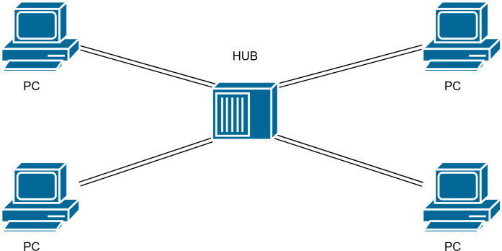

# Topology with a Switch

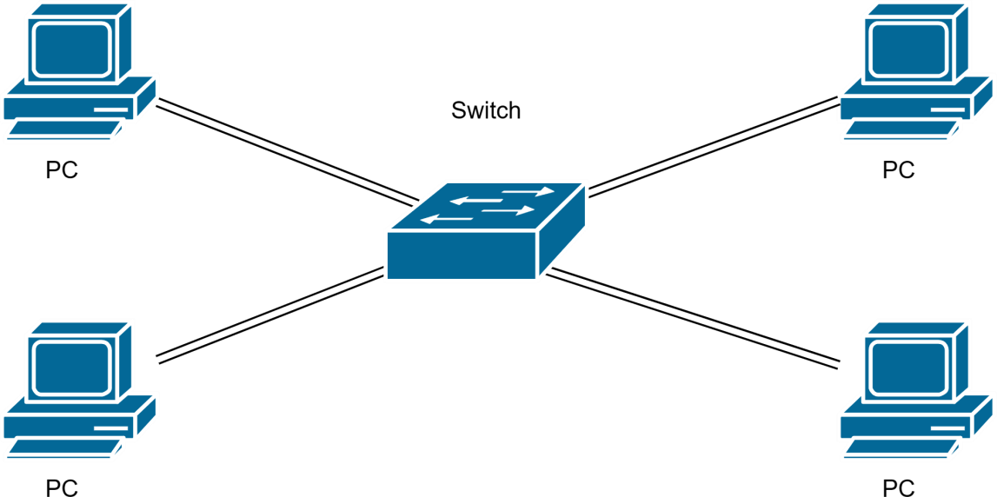

1. **Topology with two switches**

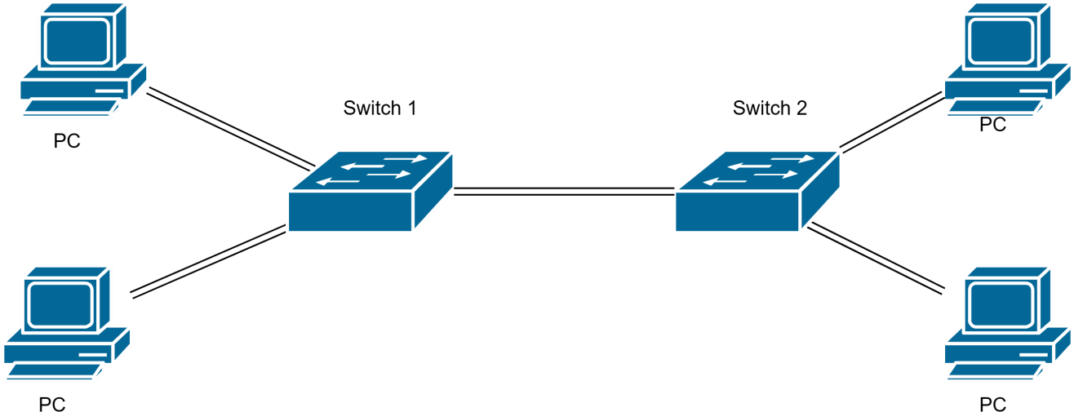

**5. Topology with 3 switches in a loop (Concept of STP)**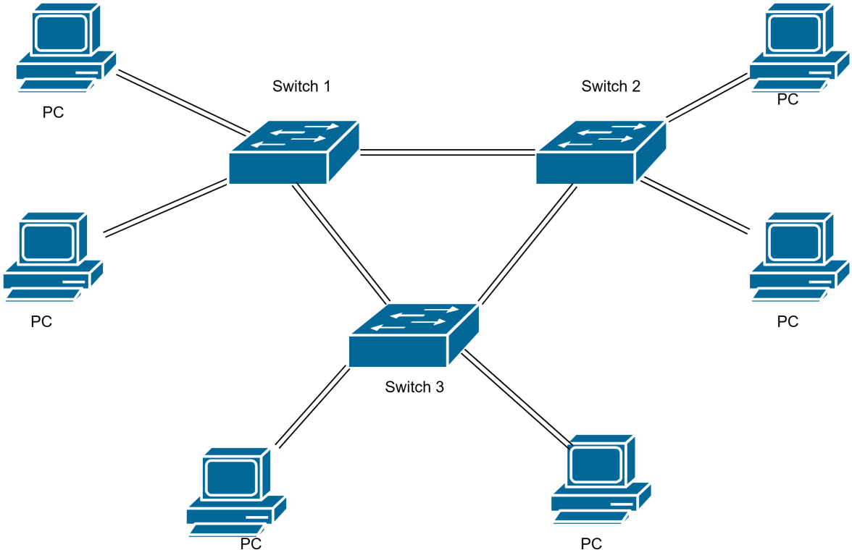

# IMPLEMENTATION:

1. **Switch :**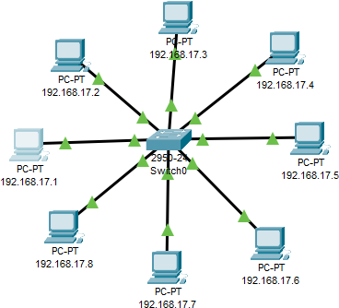

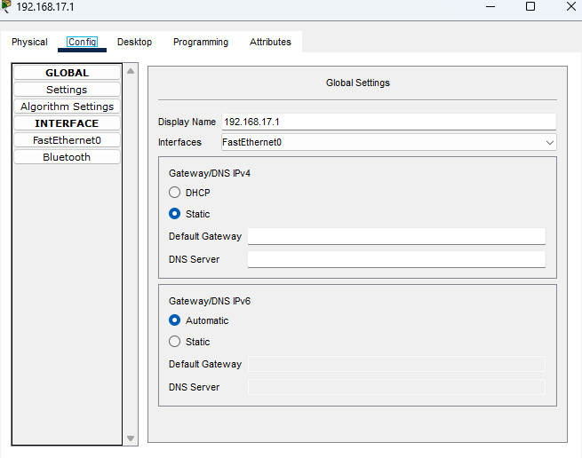

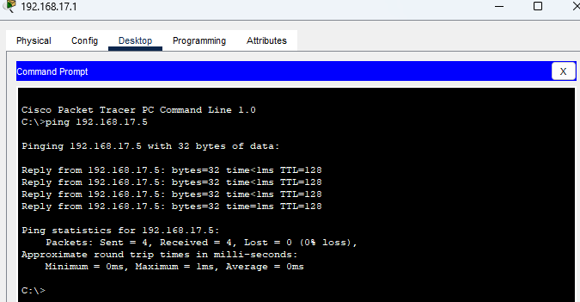

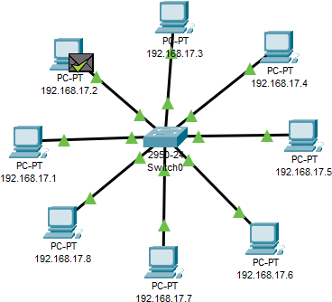

# Hub :

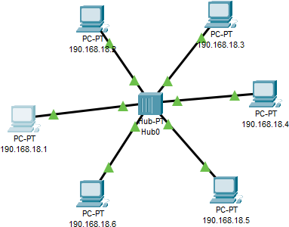

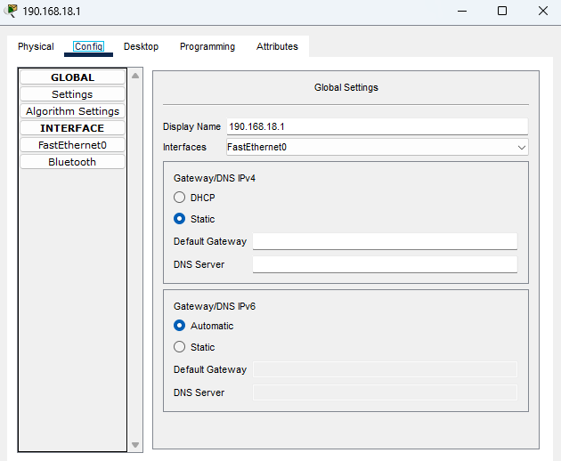

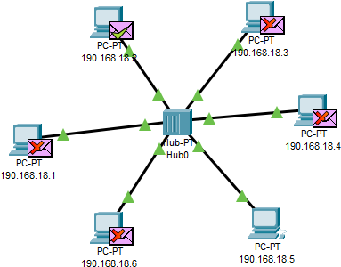

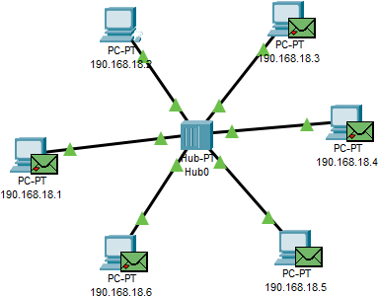

1. **VLAN :**

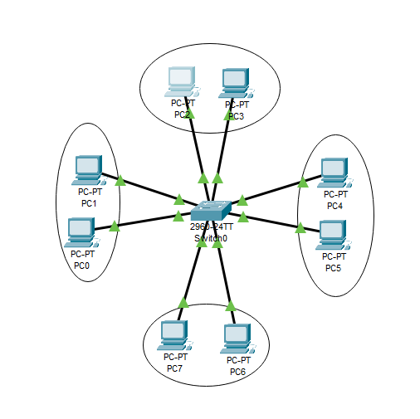

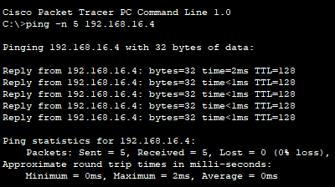

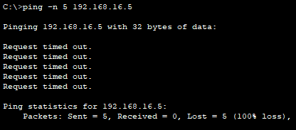

**CONCLUSION:**

This lab effectively demonstrated how to build and configure basic network topologies using CISCO Packet Tracer. You learned the differences between hubs and switches and observed the impact of network design on performance. This hands-on experience reinforced fundamental networking concepts and practices.

**Post Lab Questions**

1. **List features of CISCO packet tracer.**
   * Network simulation and visualization.
   * Support for a wide range of network devices.
   * Ability to create and configure various network topologies.
   * Real-time and simulation modes for traffic analysis.
   * Support for network protocols and configurations.
   * Educational tools for understanding network concepts.

# Explain difference between working of a Hub and a Switch in a given topology.

| **Concept** | **Hub** | **Switch** |
| --- | --- | --- |
| **Function** | Broadcasts data to all connected devices | Forwards data only to the intended  recipient using MAC addresses |
| **Layer** | Physical layer (Layer 1) | Data link layer (Layer 2) |
| **Efficiency** | Can lead to network congestion and  collisions as all devices receive the data | More efficient, reduces collisions by  sending data only to the intended device |
| **Usage** | Basic networking device, less efficient  for larger networks | Commonly used in modern networks for  better performance and segmentation |

1. **Differentiate between LAN and VLAN**

| **Concept** | **LAN (Local Area Network)** | **VLAN (Virtual LAN)** |
| --- | --- | --- |
| **Definition** | A network that connects devices within a limited geographic area  (e.g., building or campus) | A logical grouping of devices within a LAN, configured to appear as  separate networks |
| **Scope** | Localized to a specific area, allowing for resource sharing and communication within that area | Segments a LAN into multiple virtual networks to improve management, security, and reduce  broadcast domains |
| **Configuration** | Typically involves physical connections and hardware within  a single network | Configured through software on switches to segment network traffic  logically |

# Date: Signature of faculty in-charge